Visa Run and Mini-Vacation in Penang, Malaysia

You can add proximity to Penang to the long list of benefits of living in Surat Thani. What started as a visa run quickly began to feel like a mini-vacation in a unique place with ethnic diversity, architecture and myriad of amazing dining options. In 2008, George Town was awarded UNESCO World Heritage Site status, and it’s easy to see why. Departing the country after having received our non-immigrant B visas, my friend (another teacher from Surat) and I were already discussing the next time we would come to George Town.

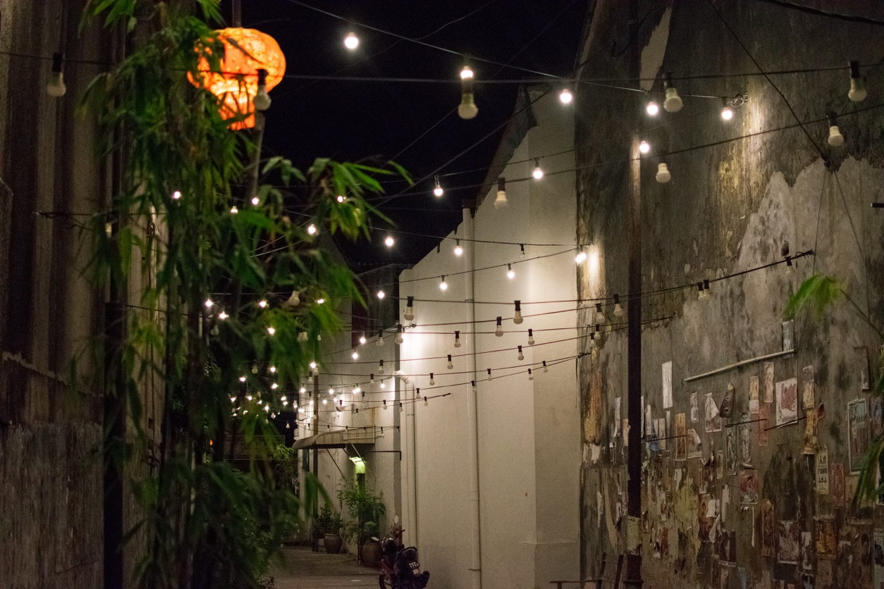

Getting to Penang

A minivan ticket to Hat Yai from Surat Thani will be between 200-250 baht. Van tickets are purchased at the Talad Kaset 2 bus station. The ride is approximately seven hours long. After arriving in Hat Yai, head to the van office and purchase a ticket to Penang; the office is easy to find. Note that you’ll have to pay an additional 50 THB for van insurance; this is required to cross the border into Malaysia. Note that you can also take the train from Surat Thani train station to Hay Yai (we did on our return trip). It’s also possible to travel entirely by train to Penang from Surat.

After another 2-3-hour ride, you’ll arrive at the Thai border. You can leave your bags in the van. You’ll head inside, give your departure card (Do not forget this) to an immigration officer and then exit. Shortly after re-boarding the van, you’ll get to the Malaysian border. Bring your bag inside as they’ll run it through a security scanner. Getting through Malaysian immigration is straightforward enough. They scan your index fingers and affix a tourist visa into your passport.

You’ll exit the van at the last stop in George Town, Penang. The van stops in front of a Rasta bar. From there it’s a 10-15-minute walk to most of the hotels, hostels and BnBs of the city center. If you have cell service through a Thai provider, you will not have access to calls, SMS or data in Malaysia. You’ll need to use WIFI at your accommodation, cafes, etc.
The Visa Process

Obtaining a non-immigrant B visa for purposes of employment in Thailand is completed at the Royal Thai Embassy Consulate located at 1, Jalan Tunku Abdul Rahman, Taman Barat, 10350 George Town, Pulau Pinang, Malaysia.

George Town, the capital city of the Malaysian state of Penang, is located at the Northeast corner of Penang Island. This is where you’ll be staying during your excursion. Although some places are too far to walk (including the embassy), nowhere in George Town is much more than a 10 or 15-minute taxi ride. In the map below, the red pin is the Royal Thai Embassy. The purple pin is a BnB we stayed at (discussed several pages down). This region is where you’ll be spending time during your excursion unless you should decide to venture out of this corner of the island.

Recently, the Penang Thai Embassy changed its process for accepting applications. Each weekday morning (except Malaysian and Thai holidays), beginning at 9:00am the Embassy begins accepting applicants. They close at 11:30am. No more than 100 applicants are allowed into the embassy each morning. That means that 100 people will be permitted in and then no more people are allowed to enter. You should therefore arrive early. We arrived at 7:30am and were the first ones in line. At 9:00am sharp, be prepared to be shepherded inside. There is a stand outside the embassy with coffee and Indian food open at 7:00am. Dress respectfully. If you’re wearing sunglasses, remove them as you enter. The embassy website states you may be barred entry due to improper attire.

After entering, you will be guided into the office (airconditioned, fortunately) where you will submit your package of application documents and 300 Malaysian Ringgit (other currencies including THB are not accepted, I did not see an ATM within walking distance of the embassy). The exact documents that are requested can vary from person to person. At a minimum, you will require a federal or state fingerprint background check from your home country, a Thai police fingerprint background check, a legibly and accurately completed visa application (blank copies available at the embassy, complete the application in capital, block letters), two appropriate passport sized (3.5cm x 4.5cm) photos stapled to your application, the necessary application forms completed by your employing school and a copy of your college degree and other relevant teacher certificates.

It is possible you will be asked for other documents such as a copy of the travel itinerary from when you first entered Thailand. It’s therefore prudent to locate any travel itinerary in your emails when compiling your application package for quick access. You may also be asked for your resume or CV. Bring a black or blue pen for completing the application form as the embassy may not have pens available. After you’ve submitted your application and payment, you will be given a receipt which shows your number in the line of applicants that morning. You must bring this the following day.

If the embassy staff requests a document that you only have a digital copy of on your phone or a USB device, you are allowed to exit the embassy to have it printed. Directly outside the embassy each morning there is a person that can print documents, take passport photos and make copies. They have a WIFI hotspot so that you may access the internet and send documents to be printed. You will pay 1-2 MYR each for copies, photos, etc.

The following day, arrive at the embassy at 2:00pm (or shortly after, depending on the number you were given the previous day) with the receipt you were given when dropping off your application. Bear in mind that the embassy closes at 4:00pm. Assuming no issues were found with your application (any issues should hopefully have been uncovered by the immigration officer the previous day), you will receive your passport with your new non-immigrant B visa. Congratulations!

Getting Around in Penang

Downloading the Grab app on your smartphone provides quick, easy access to the taxis throughout George Town. If you’re leaving from the Chinatown / Little India area, expect to pay 10-12 Ringgit to go one-way to the embassy.

We also had a good experience with a taxi driver named Carter. If for some reason you don’t have the Grab app or you would like to give Carter a try, here is his contact information.

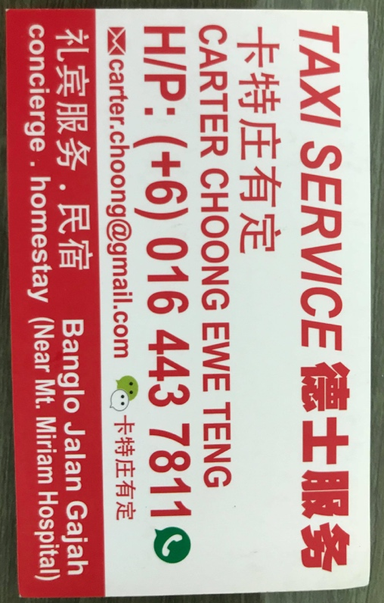

I really enjoyed walking in George Town as there’s lots of cool cafes and restaurants and interesting street art around seemingly every corner; however, I can see how some people would get tired of the heat (Penang is very hot).

Accommodations and Restaurants in Penang

I would recommend staying around Little India and Chinatown for practicality and since this is where you’ll find much of the delicious food that George Town is famous for. Alternatively, you could stay in the Gurney Drive area which is a more modern, high-rise part of George Town. I don’t have experience with this area, but it is closer to the embassy than the Little India/Chinatown area (2km vs. 5km). Either way, there are plenty of great accommodations throughout George Town, but the two below are the only ones that I have experience with.

https://www.airbnb.com/rooms/24173839

This is a really nice, quiet AirBnB located in China Town; it’s owned by a man named Louis who is easy to contact over Whatsapp if you have any questions. There’s a good noodle place directly downstairs. Along this road known as Lebuh Pantai (aka Beach Street), there are many cafes and breakfast, lunch and dinner options. I really enjoyed this location, and there’s lots of great street art and architecture on the way to Little India which is less than a ten-minute walk away.

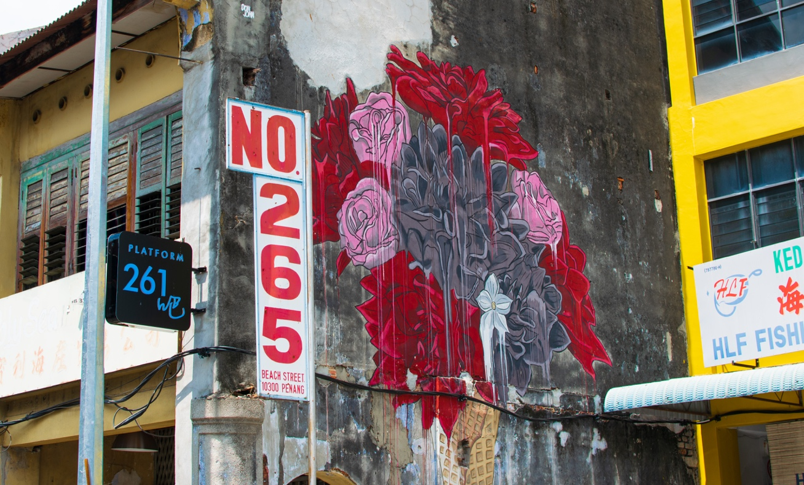

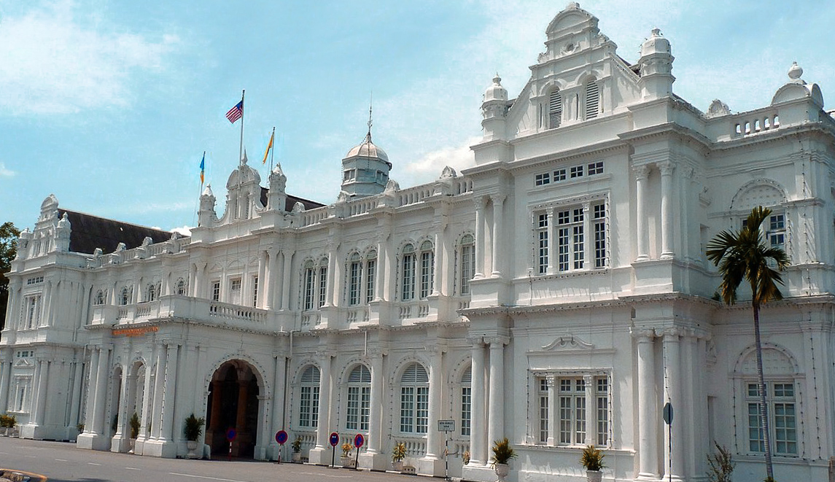

(This is George Town city hall, not the Royal Thai Embassy)

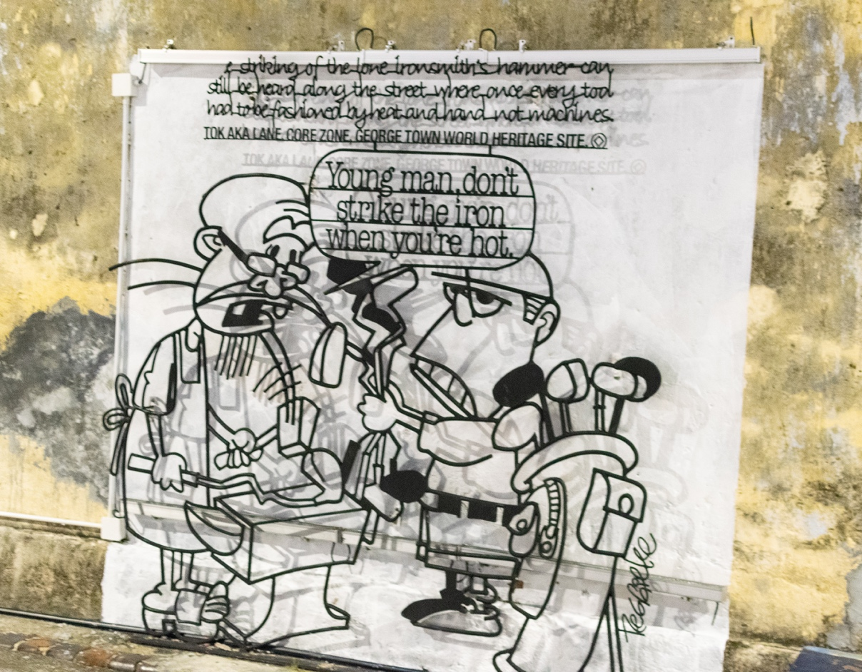

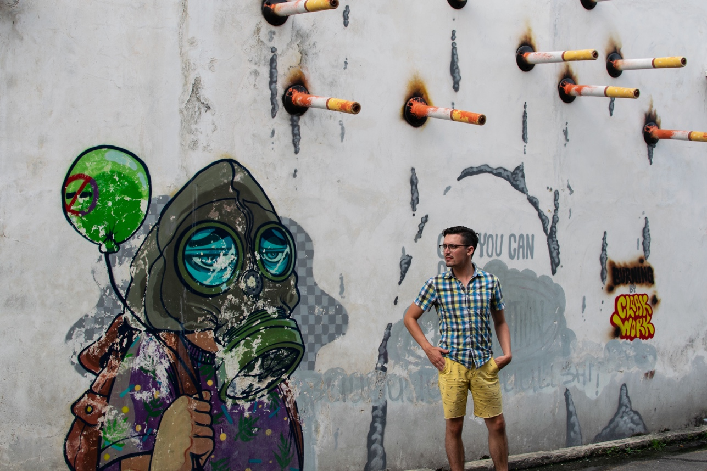

Wassup Youth Hostel is another good, inexpensive option that is a little further from Little India and China Town and the same distance from the embassy. I enjoyed staying here for one night.

Side note to keep in mind when budgeting for this trip. George Town is a little more expensive than Surat Thani though not too different from what you would pay eating out at nicer restaurants (18 – 30 MYR / 150 – 250 THB). You can find cheaper options using the same strategy you’d use in Thailand – if it looks like a small kitchen, it will be cheaper than a larger restaurant. Fantastic food abounds in this city. Good restaurants we tried include, but are certainly not limited to –

- Roti Canai – Fantastic, cheap street Indian breakfast.
- Sri Ananda Bahwan – Indian restaurant in little India. The butter chicken/paneer is incredible as is the Dosa (I believe it may be known as Tosai in Malaysian).
- Woodland Vegetarian – Another Indian joint just up the street from Sri Ananda. Good for lunch and big set menus.
- Mr. Shawarma – Really good shawarma! The chicken shawarma platter came with flat bread, fries and four or five salads for about 20 Ringgit.
- Two Buns – If we hadn’t been intent on exploring more restaurants throughout George Town, I easily could have eaten here every day. Amazing burgers, just unreal. Keep an eye out for the graffiti on the side of the restaurant that says “Burgers for the brave.”
- Ros Mutiara – More fantastic Indian food with a large menu. I’d definitely recommend this place.
- ThreeSixty Revolving Restaurant – I felt it necessary to mention this place as we’d been there for a drink one evening. It has a really nice view of the Penang skyline, and if you couldn’t tell from the name, this rooftop restaurant’s selling point is that it slowly rotates. However, for some reason on the Wednesday night we’d hung out there, no rotating. The drinks are unsurprisingly more on the expensive side, but it’s a nice spot if you’re into rooftop bars/restaurants.

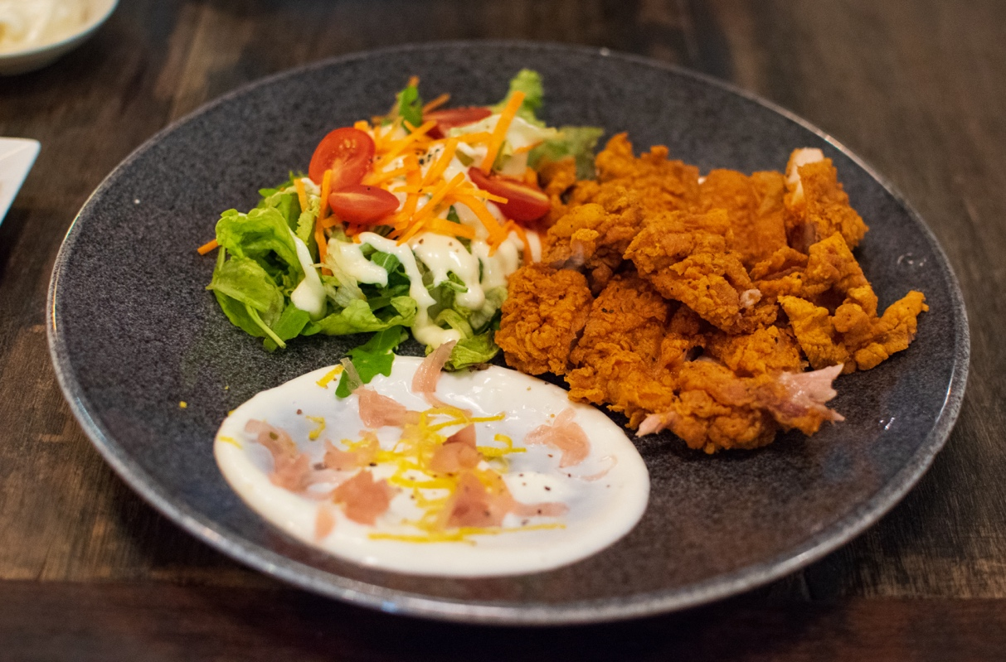

Love Lane has tons of bars and restaurants. There loads of happy hour offers around this area, you can easily spend a few evenings exploring all of them. There’s also an over-priced "Mexican" place; if you’re dying for a Mexican fix, it's decent.

In addition to the myriad dining options, there’s several beautiful temples of Chinese, Hindu and Muslim origin in George Town. We spent a while admiring them from outside but did not have time to investigate further. George Town is on an island separate from the rest of Penang, so I’d also recommend taking a relaxing walk along the water if you have a chance. Towards the northwestern corner of George Town is a quiet park which is nice to walk through.

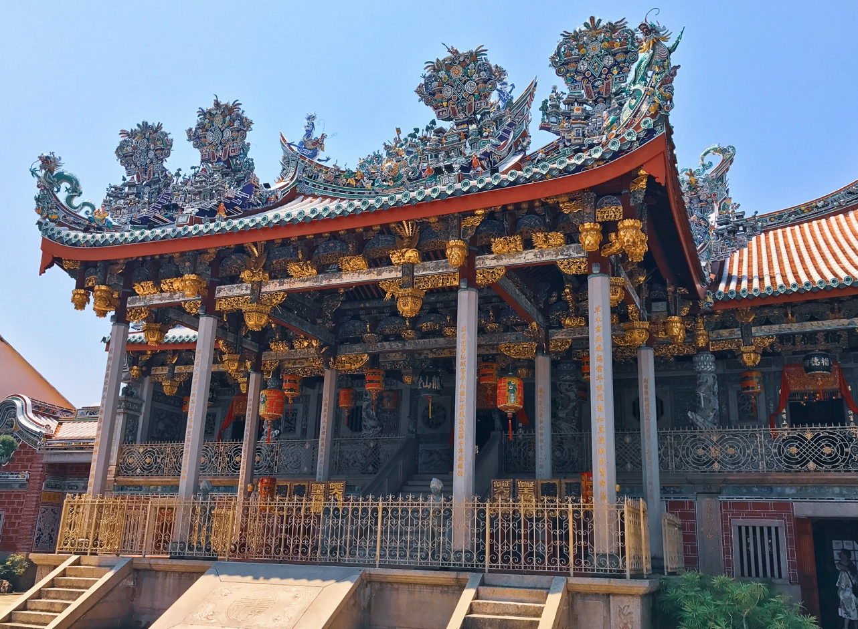

Leaving Penang

To get a ride back home to Thailand you can purchase a return ticket from the person outside the embassy that provides photos, copies, etc. We pointed out a spot on the GPS where we’d like to be picked up and clarified the street names. You can also purchase a van ticket at Jim’s Place, located on Chulia Street (Lebuh Chulia) in George Town.

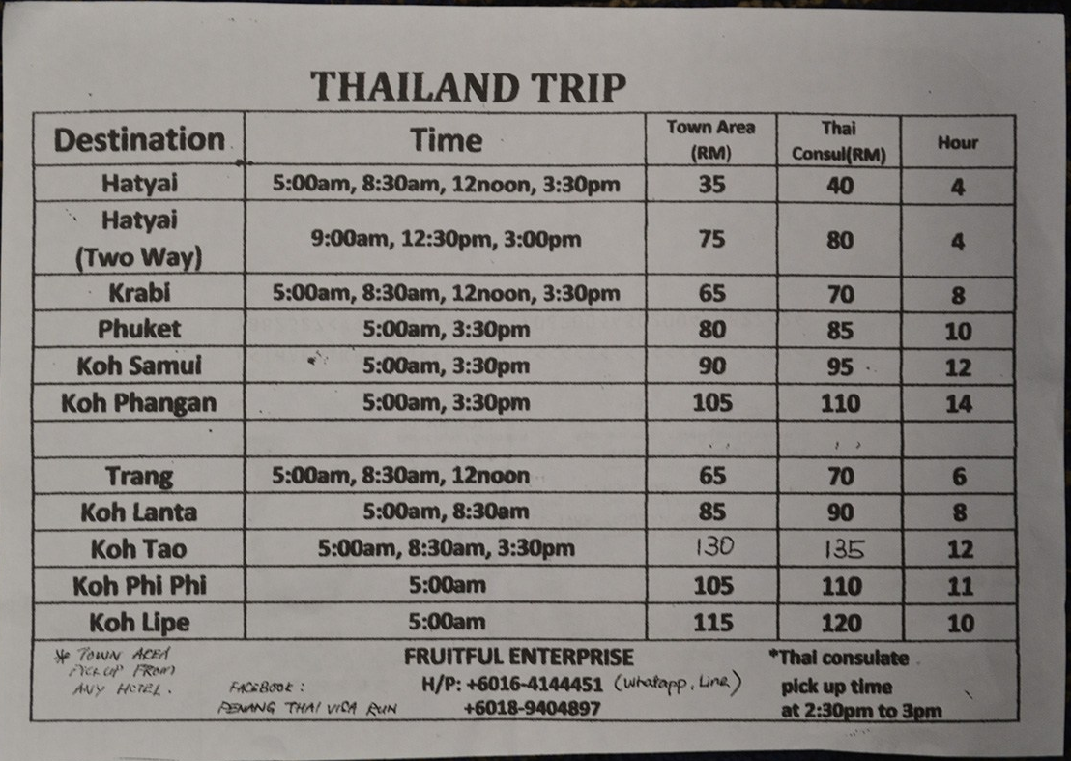
The following morning the van was a little late and I received a call over WhatsApp informing us that the driver would be there soon. Once you arrive back in Hat Yai, you can either purchase a van ticket or take the train back to Surat. Both take the same amount of time, but I would definitely recommend the train as it’s more comfortable and scenic! The train station is walking distance from the van drop off location in Hat Yai.

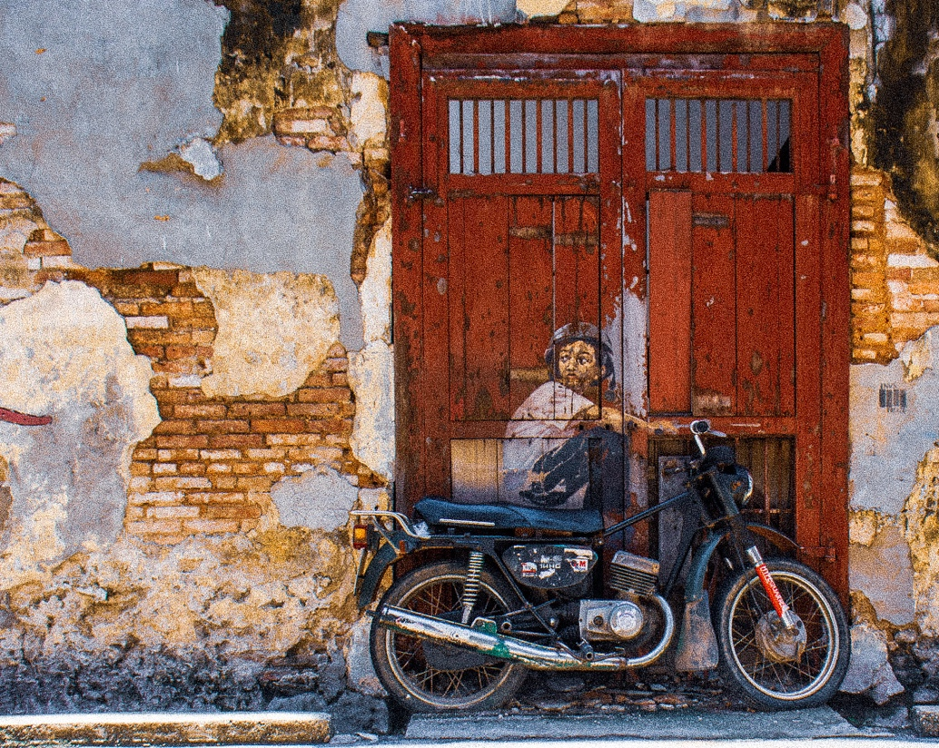

Further Exploring in George Town

George Town’s section of Penang Island blends diverse cultural history with many modern-day amenities. The remainder of the island also offers many attractions that you may wish to see, time permitting. Penang National Park is a 90-minute bus ride from the historical center of George Town. Exploring the park, nature lovers may be reminded of the lush jungles, picturesque beaches and wildlife of southern Thailand. Penang also hosts a handful of notable festivals throughout the year which seem like they’re definitely worth seeing.

