Making the Leap from Marketing to Teaching — A Quarter-Life Crisis
By Sarah Anderson

First off, I will admit that although I majored in English in college, I had virtually no formal teaching experience before I moved to Thailand and started at Thida, so I was about as apprehensive as you might imagine. I distinctly remember the several panic-stricken days before I started teaching where I questioned whether my decision to leave my full-time marketing job of three years in Virginia to move to another country and start a completely different career was altogether sane. But after six weeks of learning through trial and error, I can say that the experience has been truly rewarding, and I can’t picture myself in any career except teaching from now on. In order to hopefully help future teachers make this decision easily, here are a few things I’ve learned from and loved about my first six weeks in Thailand:

Things I love
- The look on my fifth-grade students’ faces when they start to understand something new and they’re excited about an activity
- The point when I finally started to get to know my 39 fifth-graders and some of my first-grade students on an individual level, learning how to make them laugh and understanding how they interact with each other
- When I find an activity that even my shyest students will participate in—(relays work especially well for students who are reticent to volunteer)
- Playing with my first-grade students at recess, which involves making extraordinarily long human chains, participating in the Thai version of Duck, Duck, Goose, losing at Rock, Paper, Scissors, and creating archways with our arms that fall and trap as many students going underneath as possible.
- High fives, fist bumps, handshakes, and hugs from my students—there is almost nothing better than being mobbed every day by dozens of first graders who want a group hug and a million high fives/fist bumps as soon as they see you.
- Running into students around town—they are sometimes very shy, but always excited to see you; I came across one of my very shy fifth-graders outside of school, and she opened up to me more than I ever would have dreamed, telling me about the work she had done on her science project over the weekend, taking me to meet her baby sister, and showing me pictures from a recent trip she took to an aquarium.
Things I’ve learned

- How to create games and science experiments with practically no resources, such as making a Twister board out of Post-it notes and discovering how to light up a lightbulb with a balloon
- Be careful about erasing the whiteboard with your hand and then absent-mindedly touching your face while teaching, or you will be met at the end of class with shouts of “Teacha, you have blue on your nose!” and “Teacha, you have blue on your eye!”
- Always look at worksheet pictures closely, even if it is a worksheet specifically designed for ESL students in Thailand and created by the organization that you took your TEFL certification course with. Otherwise, you may end up finding out almost too late that there is a cartoon of a woman with exaggeratedly long legs that you have to quickly skip over, causing your students to plead the rest of class to be able to see question number 3.
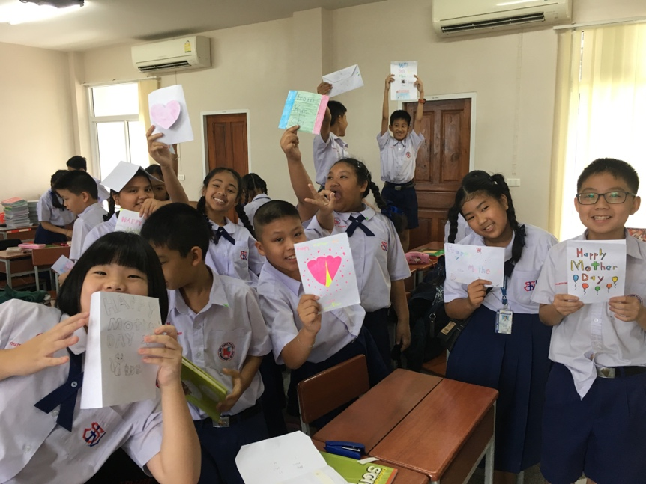
- You can never predict how a day at school will play out—one week half of your students might disappear without warning, and when you ask where they are, a student will reply, “Teacha, they are camping.” On another day, you might find yourself watching Ice Age and making Mother’s Day cards in all your classes while your fifth-grade students go in and out of the classroom for an hour because they keep thinking their parents are coming to pick them up.
- In Thailand, there is a specific color for each weekday, and if someone gets the wrong information about a color for that day, it wreaks havoc and causes Thai teachers to think you do not know what day it is.
- Do not say “one second” without thinking or at least one student will reply with a smirk, “Teacher, it has already been one second.”
- If you need a banana for a science experiment, but all the bananas are gone that morning and the only substitute is a “butter sandwich” (I’m not kidding), the 7/11 employees will take the sandwich you are buying and toast your science experiment without warning.
- Only greet someone formally once a day, even if you run into them several times, or you will be met by endless teasing.
- If you do a science experiment with fifth-grade students that involves letting them put their foot through a plastic bag to test its breaking point, bring LOTS of bags.
- Dogs are to be feared here, as I have been chased twice already, once on foot by a pack of dogs and once even when I was on a motorbike.
- Don’t ride over gravel too quickly on your second day driving a motorbike, or you will find yourself in the middle of the road with a bike on top of you and then limping into the nearest pharmacy, looking like your elbows and knees have been through World War III for several weeks.
- On that note, there is a very hot pipe underneath the motorbike that I was unfortunate enough to discover with my leg a few days later, earning myself a second-degree burn as well.
- Avoid ice cream that contains what looks like green and yellow candies because it is actually ice cream with corn and green beans. Unless that’s your thing—in that case, by all means eat all the veggie ice cream your heart desires because it’s only 10 baht!

